**Mini Project Report**

on

**“Employee Management System”**

**Submitted by**

**PES1UG20CS804 : SHRADHYA RAKSHIT**

**PES1UG20CS816 : NAGESH B S**

**PES1UG20CS829 : SHRAVAN B**

**1: Brief Description of the project**

# Introduction:

Employee Management System is essentially software designed to keep track of employee details in any company. It stores information about their employees’ personal information. It is simple to understand and is user friendly.The goal of “Employee Management System” is to create a work center scheduling system.

**Objective :**

In this world of growing technologies everything has been computerized. With the plethora of work opportunities the human workforce has increased. Thus there is a need for a system which can handle the data of such a large number of employees. This project simplifies the task of maintaining records .The objective of this project is to provide a comprehensive approach towards the management of employee information such as Employee details, Payroll Management and Leave management.

* A user friendly front-end for the user to interact with the system.

# Scope :

The scope of this project will be limited to the following:

* Employees will have access to their personal profiles and will be able to edit their details and they can request for a leave whenever required.
* Complete elimination of paperwork in leave management by enabling an employee to apply for leave as well as check their leave status through the system.
* The admin will add an employee details,update employee details,view all employee details,Manage the leaves requested and manage payroll.

**Functional Requirements:**

* Employee must be able to login to the system
* Employee must be able to edit his details.
* Employee must be able to apply for the leave

**Non-Functional Requirements:**

* **Hardware Requirements:**

MEMORY SPACE: Minimum - 32 MB Recommended- - 64 MB

HDD - To install the software at least 2 GB and the data storage is depending upon the organizational setup.

PROCESSOR - Intel Pentium IV, 1GHZ or above

RAM - 256MB or above

KEYBOARD - Standard 104 Keys(QWERTY

* **Software Requirements:**

OPERATING SYSTEM – Windows 10 professional

DEVELOPING LANGUAGE - JAVA(jdk-5)

DATABASE - MICROSOFT SQL SERVER 2005

**Modules:**

* + **Login module:** This module is created for login details of admin and the employee. There are different login details provided and both can login using their respective user id and password.
  + **Manage employee module:** This module enables admin to add and edit employee records. It is also for viewing each and every employee details by the admin.
  + **Delete module:** This module is created to delete any employee details.
  + **Search module:** This module is an added feature in this system which enables it to search employee records easily using employee id.
  + **Payroll module:** This module is an added feature in this system which enables adding employee salary details.
  + **Request for leaves module:** This module is an added feature in this system which enables employees to request for leaves.

**2: Use Case diagram:**

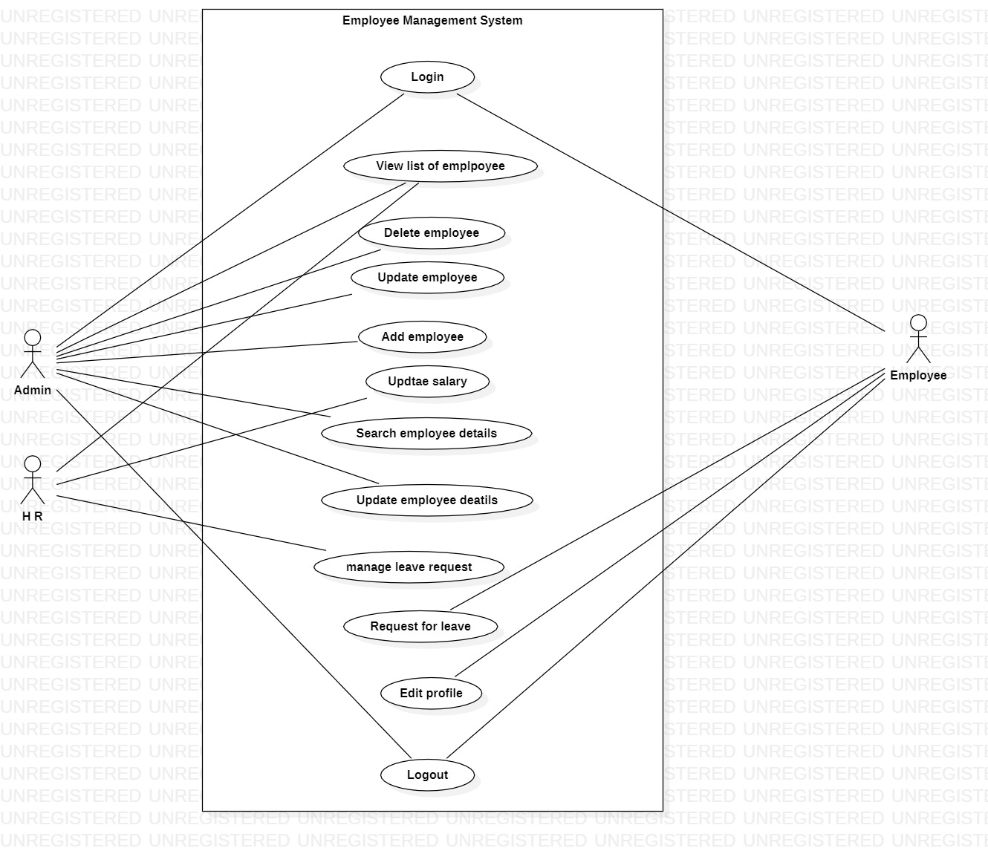

**3: Class Diagram:**

